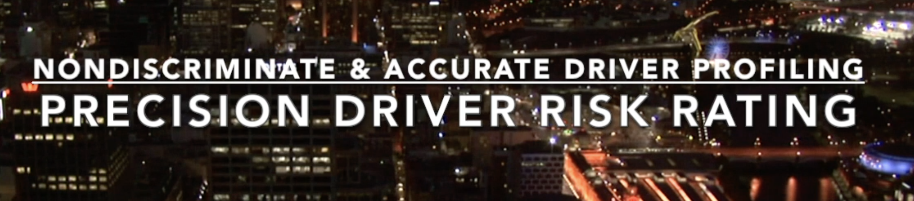

Anything from your age, sex, distance you drive or tickets to raise your rates?
Is this fair or accurate? A rich person can afford to fight tickets keeping rates low?
Insurance should be about risk, not who is richer or has better luck in court!

”Progressive the industry leader in rapidly-expanding “Usage-Based Insurance” category for 15 years since it first started exploring UBI. Snapshot, accounting for $1 billion in premiums"* is leading the trend on UBI, however Snapshot has no clue what is really going on and can not m

The algorithm determining your insurance rate uses acceleration, heavy breaking, and sudden movements against you and you never know when the occurrences affect your insurance rate. Making turns, getting on freeways, accelerating at green lights and more adversely affects your insurance rate. People entering a freeway at 40MPH are protecting their insurance rate while simultaneously raising the chance of accident for everyone else.

Turns also affect your rate. If a car pulls out from a driveway and you avoid it by braking and swerving... Snapshot registers your actions as reckless driving and raise YOUR insurance rates even though you avoided the accident. Another example, if you brake suddenly because a child runs into the street in front of your vehicle, you save a child's life but Snapshot detects this as unsafe driving and raises your rates! It makes no sense. Unfortunately, driving in the mountains also raises your insurance rates because Snapshot detects the turns and braking before going around sharp corners but thinks you are being a reckless driver.
Kenometer is so precise it distinguishes between all types of driving patterns including racing, towing, downshifting, burnouts, over revving, uphill and downhill driving, etc. The best thing about Kenometer is the information is not hidden! Parents can use Kenometer to see EXACTLY how their kids are driving, and where! Now we can validate if our insurance rates truly reflect our driving patterns, watching it adjust when we change our driving habits.

