Two cars travel 100 miles. One car averages 1500 RPM, the other car averages 6000 RPM. Which car has the most wear and tear? Most car manufacturers, leasing companies, and insurance companies only care that the odometer reads “100 miles”.

The TRUTH: Vehicles do not drive themselves. Engine wear is a direct result of a driver’s actions - this needs to be accounted for when examining vehicle usage.

Kenometer compiles accurate and precise engine and transmission history, pinpointing engine and transmission wear. Normally undetected, Kenometer will isolate how an individual is driving during any given period throughout a vehicle’s history. If determined a vehicle’s owner/lessee was abusive or negligent - such as constant red-lining, (especially during engine break-in), drop shifting, and racing, that abuse should lie with the driver(s), not the manufacturer.

Kenometer gives companies the ability to protect themselves in the event of engine or transmission failure. Manufacturer warranties can be voided if mistreatment of a vehicle is able to be documented.

Vehicle Lessees currently pay extra for mileage overages, but why there is no penalty for excessive engine revolutions? Extra revolutions create additional heat, friction, and general engine wear. These extra revolutions can cause engine failure much sooner.

Kenometer utilizes patented technology to protect a vehicle, solving a century old problem – how has this vehicle previously been operated? With this problem solved, the Kenometer can account for all engine wear; making it the most accurate vehicle monitoring system available.

Kenometer will:
- Provide complete engine history data
- Detect driver negligence and abuse
- Recognize driver usage patterns
- Prevent odometer fraud

Average Revolutions per Mile

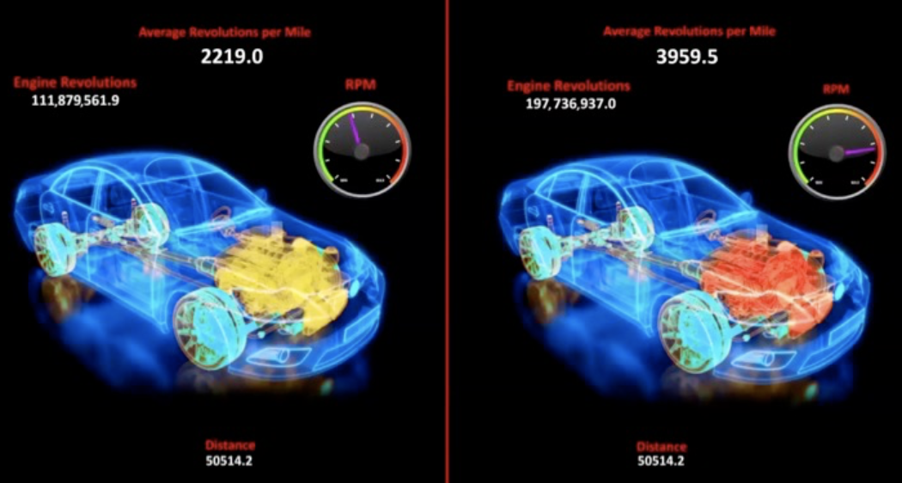

Vehicles travel upwards of 250,000 miles if cared for properly. However, did you know that NASCAR estimates that a racing vehicle will only drive 15,000 miles before engine failure?

Mileage should not be the sole factor in determining a vehicle’s engine usage. High RPM creates extra heat and friction - greatly reducing the lifespan of any engine. An engine running at 6000 RPM is rotating 100 times a second – that’s over 1 MILLION times in 3 hours!

RPM usage tracking has eluded the auto industry for a century, as data is either too great, or too complex to determine reasonable conclusions. Averaging a vehicle’s RPM also doesn’t provide accurate data. For example: If a driver takes a vehicle to the racetrack and races for 15 minutes at 6000 RPM, then lets the vehicle idle for 45 minutes, average RPM will correspond to 2000 RPM - completely hiding the racing abuse the engine has just endured.

Kenometer is the most accurate method to monitor driving patterns, and determine negligent/abusive driving. Kenometer pinpoints what a driver was doing at any time, and precisely determines whether vehicles with similar odometers have experienced more/less abuse from previous drivers.

Fleet Management, Leasing, Car Rental, and Insurance companies and more will increase profit by millions without the need to increase sales. Patent: http://uspto.gov - US 9299109 B2
Kenometer is designed to generate MILLIONS in extra revenue for the transportation industry!
Kenometer is the best way to collect REAL engine history

