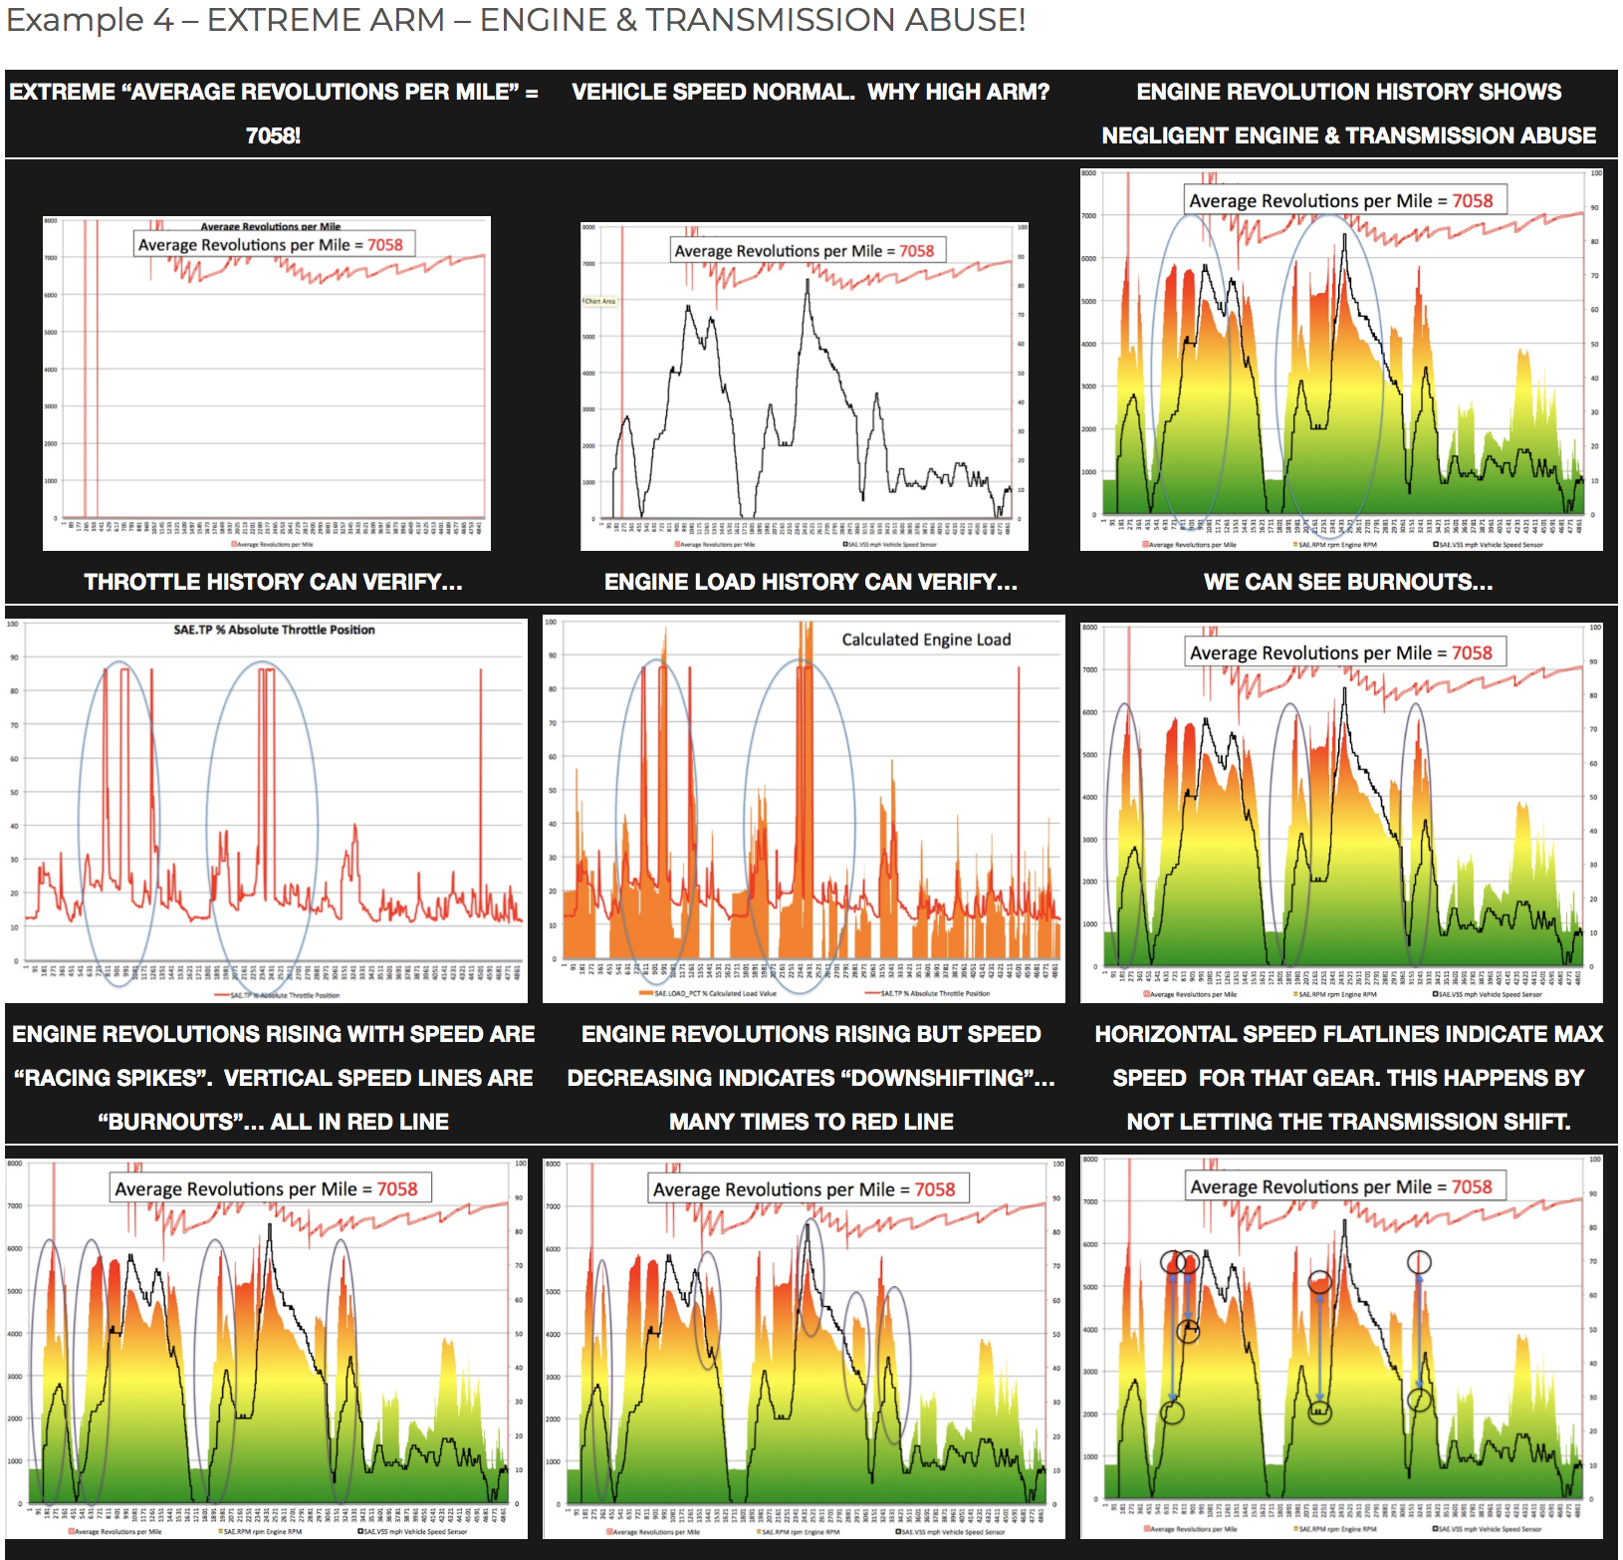

The operator of this vehicle was trying to destroy the Engine & Transmission!
Companies won’t be victim to engine and transmission abuse because of destructive drivers. Negligent operators are identified and held liable for the extra wear and tear.

