More than 450,000 vehicles are sold each year with false odometer readings, draining American consumers out of more than $1 billion annually making odometer fraud one of the top crimes against property in the United States. www.nhtsa.gov

The Consumer Federation of American estimates that 1 in 10 used vehicles (10%) have had their odometers rolled back, and according to CarFax, the number of cases of odometer rollbacks is rising each year. At least 1.5 million cars have incorrect mileage and at least another 200,000 cars are tampered yearly. Despite increased safety measures and stringent laws, consumers still fall victim to odometer fraud daily and the sad fact is that with odometer correction software readily available via the Internet, odometer fraud is easier than ever, and harder to detect. CarFax.com

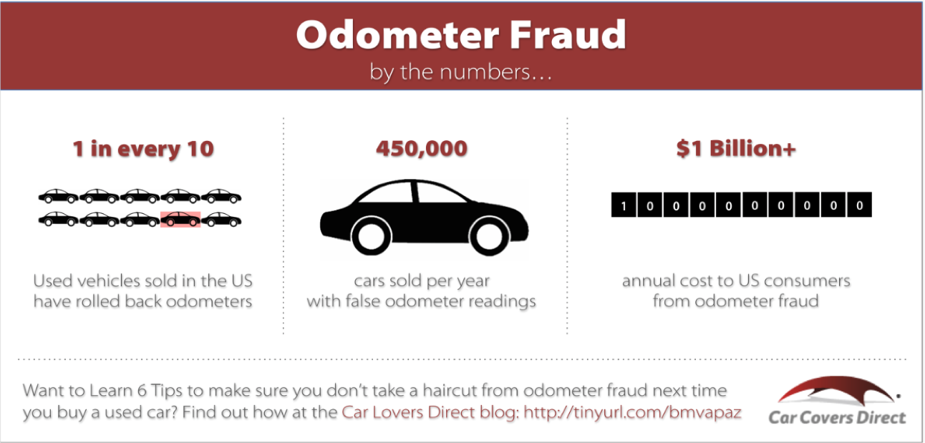

When someone disconnects the odometer… miles are not counted. There are many reasons why someone would do this including preserving the retail value of their car, reducing insurance rates by reporting less mileage during a policy period and soon, avoid or get out of paying the road charge! We need to stop rewarding those who cheat the system.

LET’S STOP ODOMETER FRAUD NOW!

